A
Summer Project Report On

“A Study on The Sales Promotion Activities”
At
TRIPTY DRINKS PVT LTD, PEPSI
CUTTACK
For the Partial fulfillment of the degree of Master of Business Administration
M.B.A (2007-09)

Under the Guidance of

Prof. Ashutosh Mishra

Submitted by

Biswabhuswa Nayak
Regd. No. 0706260066
Submitted to
BIJU PATNAIK UNIVERSITY OF
TECHNOLOGY, ROURKELA

DECLARATION

I, Biswabhusan Nayak hereby declare that the summer project report titled “A study on sales promotion activities” written and submitted to ROURKELA INSTITUTE OF MANAGEMENT STUDIES by me is my own and its equal copy has not been reproduced to any other institution/university or published anywhere else.
I understand that such reproducing is liable for punishment in any way the university deem fit.

Place: Rourkela Biswabhusan Nayak
Date: Regd. No.-0706260066
MBA

COMPANY GUIDE CERTIFICATE

This is to certify that the summer project titled “A study on the sales promotional activities” at Tripty Drinks Pvt Ltd is an original work of Mr.Biswabhusan Nayak, student of Rourkela Institute of Management Studies, Rourkela and is being submitted for partial fulfillment of the award of the Master of Business Administration (MBA) degree of Biju Patnaik University of Technology, Rourkela. The final compilation of the report was also done under my guidance and it has not been submitted earlier to anywhere else.

Place: Rourkela Biswabhusan Nayak
Date: Regd. No. - 0706260066
MBA

Sanjaya Gupta(HOS), Pepsi
Name & Signature of the guide

CERTIFICATE OF THE INSTITUTE GUIDE

This is to certify that the project titled “A STUDY ON SALES PROMOTION ACTIVITIES”

is an original work of Mr. Biswabhusan Nayak bearing University Registration Number 0706260066 a student of Rourkela Institute of Management Studies, Rourkela and is being submitted in partial fulfillment of the requirements for the award of the degree of Master of Business Administration of Biju Pattnaik University of Technology, Rourkela. The summer project report has not been submitted earlier to this University or to any other University / Institution for the fulfillment of the requirement of a course of study.

.

Date: Ashutosh Mishra
Name and signature of the guide

ACKNOWLEDGEMENT

I am thankful to Prof. Rita Pattnaik, Chairperson of Rourkela Institute of Management Studies who showers her ever graceful guidance by extending her cooperation in giving an opportunity to do my summer project report on “A study on sales promotion activities” at Tripty Drinks Pvt. Ltd.

I take this opportunity to place on record my grateful thanks and sincere gratitude to Mr. Sanjay Gupta (HOS) Tripty Drinks Pvt Ltd, Cuttack, who has given me this opportunity to conduct this project work in this organization. My study would not have been completed if I had not been able to get the support and guidance of Mr. Aswini Ku Das (TDM) and other employees of the organization.

I am also highly indebted to my esteemed guide Prof. Ashutosh Mishra (Faculty in RIMS, Rourkela) whose continued and invaluable guidance can never be forgotten by me and without whom, this study could not have got the present shape.

Lastly, I would express my grateful thanks to my family members and my friends who inspired me to put in my best efforts for the preparation of the Project Report.

Place: Rourkela Biswabhusan Nayak
Date: Regd.No-0706260066 MBA

CONTENTS

Chapter No. Topic Page No.
1 INTRODUCTION
1.0 Introduction 10
1.1 Introduction about the study 10-13 1.2 The Industry 14-15
1.3 Soft Drinks in India 16-20
1.4 Market growth rate and demand trend 20
1.5 Objective of the study 21
1.6 Scope of the study 21
1.7 Methodology of the study 21-22
1.8 The survey 22-23
1.9 Sources of data 23-29
1.10 Limitation of the study 29

2 COMPANY PROFILE
2.0 History of the Tripty Drinks Pvt. Ltd 31
2.1 Vision 31
2.2 Mission statement 32
2.3 Philosophy 32
2.4 Organizational structure 33
2.5 Corporate Social Responsibility 34
2.6 Majors competitors 34-35
2.7 HR Practice 35-37
2.8 SWOT Analysis 38-40
2.9 Product and Technology 41-42
3 EMPIRICAL STUDY 44-52

4 FINDINGS, SUGGESTIONS & CONCLUSION 54-57

BIBLIOGRAPHY

ANNEXURE

EXECUTIVE SUMMERY OF TRAINING

PepsiCo is a world leader in a convenient food and beverages in 2007, with revenues of more than & 32 billion and more than 1, 57, 000 employees. The company consists of Frito-lay North America PepsiCo Beverages North America, PepsiCo International and Quaker Foods North America. PepsiCo brands are available in nearly 200 countries and territories and generate sells and the retail level of about & 85 billion. PepsiCo is the world’s premier consumer Products Company focused on convenient foods and beverages.

PepsiCo is India produces healthy financial rewards to investors as it provides opportunities for growth and enrichment to employees, business partners and the communities in which it operate.

The project was undertaken under the guidelines of Orissa, Tripti soft drinks limited, an franchise of PepsiCo limited to survey the market of cuttack and outer cuttack in order to know the problems faced by distributors and the retailers and to recommend the company how to solve these problems.

Chapter – 1

- Introduction about the study
- The Industry
- Soft Drinks in India
- Market growth rate and demand trend
- Objective of the study
- Scope of the study
- Methodology of he study
- The survey
- Sources of data
- Limitation of the study

1.0- INTRODUCTION

“Good marketing is no accident, but a result of careful planning and execution. Marketing practices are continually being refined and reformed in virtually all industries to increase the chances of success. Marketing excellence is rare and difficult to achieve. Marketing is both “art” and “science” –there is constant tension between the formulated side of marketing and the creative side.”
The world economy has undergone a radial transformation in the last two decades Geographical and cultural distance have shrunk significantly with the improvements in the production, transportation and communication. These advances have permitted companies to widen substantially both these markets and their supplier sources. And thus the role of marketing becomes wide.
Marketing is the specialization subject of MBA curriculum. When a flood of consumer products are coming into the market, every company needs people specialized in marketing to promote their product.
“Marketing deals with identifying and meeting human and social needs. One of the shortest definitions of marketing is “meetings needs profitably.”
The 21st century is the era of Advertising, Marketing and Sales Production; Marketing is to convert social needs into profitable opportunities. As it is said “Marketing thinking starts with the human needs and wants”. Apart from basic necessities of air, water, shelter and clothing, every person has strong desire for recreation and entertainment. They have strong preference for particular brand of basic and services. Marketing serves as the link between the society’s needs and its pattern of Industrial response.
Beverage industry is one of the fast growing industries in India. We can divide Beverages into two sections i.e. Alcoholic & Non-alcoholic. The non-alcoholic drinks are soft drinks that can be further classified Cola, Lemon, Orange, Mango and Apple segment.

1.1 INTRODUCTION ABOUT THE STUDY
I was assigned to study the promotional activities of Tripty Drinks Pvt. Ltd. Promotional activities play a greater and important role in the entire marketing effort being carried out by Tripty drinks Pvt.Ltd, “to generate more sales as well as to create and maintain an image of its product”.
Thus Tripty drinks Pvt. Ltd carried out its promotional activities as a controlled and integrated program of communication and material design to present its soft drink to the prospective customer. It also helps in communication the need satisfying qualities of soft drink, to facilitate the sales and eventually to contribute towards the profit in long range.
The tools used by Tripty drinks Pvt. Ltd, for fulfilling the various purposes of its promotional activities are the following:-
- Point of sale display
- Dealer’s sales contest
- Sales promotion through special event market
- Advertising
- Incentives
- Games
Point of Sale Display:
A sensible man does not have to go far to find out whatever a common panwala knows that people buy with their eyes. Every item on sale in a shop is displayed in front where people can see it at first sight.
It is the same with all the shops and vendors in towns either selling consumer or selling soft drinks. Rather in selling a product like PEPSI display is more than help, it is an essential element because soft drink is bought on impulses on the spur of the movement. Thus the product is tested when it is brought at people’s attention.
Dealer’s sale contest:
Another method of sales promotion being used by the Tripty drinks Pvt. Ltd., through its distributors is to conduct dealer’s sales contest during the peak seasons i.e. during April to July. In it the dealers are given prize in the form of cases of soft drinks. In the contest at first his or her respective distributors according to there categorize each dealer. And then each distributor fixes a target of minimum sale for each category to which every dealer according to his or her category has to achieve during the contest period.
The dealers achieving highest sales over and above the target set is giving the awards as under, the order of prizes announced are first prize, 2nd prize, and 3rd prize in terms of number of free cases of soft drinks which was Pepsi space club 2006 programme.

Special event market:

The dealers at special event sports place the banners and stall of Pepsi’s product like picnic fates cricket test match, social are also used to cater the people. It helps in promoting the sale as well as in creating an image product.
Sales man contest:
Sales man contest are held to motivate the sales man. Sales man contest are held to motivate the sales man. Under the scheme salesmen are given monetary incentive on the basis of sale made in their given route.
Media planning:

A very important part of advertising is to decide the medium of advertising and how much to spend in each media:-
Newspaper & Magazines, Radio, TV, Hoarding, Product of sales materials (paintings, glow signs, D. Board)
Advertising is one of the important factors which all put together results sales. It has to be backed by the distribution network, effective servicing, dealer, goodwill and so on. Thus advertising has to be very carefully woven with the entire demands of marketing.
MERCHANDISING/ DISPLAYS
Proper merchandising and display at the store level promotes sales; it promotes the consumer to switch over to the displayed brand ignoring existing brand loyalties; it persuades him to buy “now” rather than latter; and it makes him buy more than the originally intended quantity. All these are essentially sales promotional functions. While advertising can only make a consumer aware of the product or generate a desire for it, merchandising/ display often motivates a consumer to buy a product instantly. Point of purchase displays are one of the most widely used sales promotions tools. With the proliferation of brands, innovative displays have become a prerequisite for success. In the store brands compete with each other for consumer’s attention.

Display Enhance Counter Pull
Display at the point of purchase can be rightly describe has a “clincher” in the marketing process. When awareness and interest has been created in the consumers mind through advertising and other promotional measures, a good display in the store can help to clinch a sale. The displays are also effective in inducing brand switching. A consumer normally goes to a retail outlet to purchase his usual brand. At the retail outlet, a good display of a competiting brand can command his attention and he may buy the competing brand. In other word Good display can lead to impulse buying and brand switching. A good display is the surest way to attract the consumers. It pulls the consumers to the consumers. In fact, displays have their origins in the age old saying that “goods well displayed are half sold”.
Display can be of various types- window display, wall display, counter display, aerial display, or floor display, depending on where it is fixed. Display materials to constitute a large spectrum, like posters, danglers, stickers, mobile wobblers, steamers, balloons, etc. To enhance the display effect, manufacturers use several gadgets and approaches. Illuminated designs, motion displays, sky writings, etc., add to the display effect. Some companies organize display units locate them at vantage points within the store to attract store traffic. Skillfully designed and strategically located display units can enhance the
sales appeal. More and more firms are going in for innovative displays to give their brands visibility in today’s crowded shop shelves.
Pepsi Cool Zone:
Pepsi, for instance, set up “cool zones” in outlets to create a visual effect. These zones house Pepsi display racks next to its visicoolers, both stocking the entire Pepsi range in a preset format- the products horizontally, at eye level, and in different sizes down the racks with selling price on. Companies are also using the technique of mass display. Within the limited space available in the retail store, big stocks of a given brand are artistically arranged to gain attention. Customized racks are also being used for display effect. Now the Pepsi has launches a SPACE CLUB ’06 on this regard. Pepsi space club’06 is a trade promotion which is internal affair between the company and its trade.

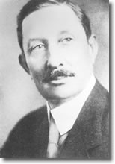
1.2- INDUSTRY
HISTORY OF PEPSI-COLA INDUSTRY.
The Pepsi-Cola story itself begins with a drugstore in New Bern, North Carolina, and a pharmacist named Caleb Bradham. Bradham's aim was to create a fountain drink that was both delicious and healthful in aiding digestion and boosting energy. It would be free of the impurities found in many bottled health tonics, and it would contain none of the stronger narcotics often added to popular fountain drinks.

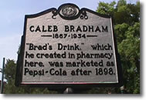
As most pharmacies in 1896, Bradham's drugstore housed soda fountain where the small-town clientele would meet to socialize. Bradham's establishment even featured a kind of primitive jukebox, which for a nickel would entertain the listener with the latest musical selections rendered by violin or piano or both It was at such convivial gatherings that Bradham would offer his latest concoction. Over time, one of his recipes became known as Brad's Drink. A member of the press declared, "It has sparkle and just enough acidity to make it pleasant." Soon its popularity would exceed the boundaries of New Bern. The cellar of Bradham's drugstore served as the original site of Pepsi-Cola syrup manufacturing. Electing to start his new business on a small, manageable scale, Bradham based his operation on familiar territory. Ingredients were hauled downstairs to cramped quarters where they were mixed together and then cooked in a large kettle. The syrup was subsequently poured into one-gallon jugs and five-gallon kegs to be shipped to customers. By 1902, the demand from surrounding drugstores increased so dramatically it dawned on Bradham that Pepsi-Cola was something special. On December 24, 1902, he filed incorporation papers with the state of North Carolina; in these, he indicated his plans for corporate branches in Virginia, Maryland, Pennsylvania, and New York. PepsiCo, Inc. is currently one of the most successful consumer products company in the world with annual revenues exceeding $30 billion and has more than 480,000 employees. PepsiCo, Inc. began as a successor to a company incorporated in 1931, known as Loft Inc. Once known as PepsiCo Cola, the company expanded its business and adopted its current name, PepsiCo, after a merger with Frito-Lay in 1965. This merger dramatically increased PepsiCo's market potential and set the foundation for the company's tremendous growth. PepsiCo’s products are recognized and are most respected all around the globe. Currently, PepsiCo divisions operate in three major US and international businesses: beverages, snack foods, and restaurants. In each of these businesses, PepsiCo has attained a leadership position as being the world leader in soft drink bottling g, the world largest snack chip producer, and the world largest franchised and company operated restaurant system. The corporations increasing success has been based on high standards of performance, marketing strategies, competitiveness, determination, commitment, and the personal and professional integrity of their people, products and business practices. PepsiCo's overall mission is to increase the value of our shareholders' investments through sales growth, investments and financial activities. PepsiCo believes their success depends upon the quality and value of their products by providing a safe, whole some, economically efficient and a healthy environment for their customers; and by providing a fair return to their investors while maintaining the highest standards of integrity.
Pepsico headquarter
PepsiCo world headquarters is located in purchase, New York, approximately 45 minutes from New York City. Edward Durrell stone, one of America’s foremost architects, designed the seven-building headquarters complex. The building occupies 10 acres of a 144-acre complex that includes the Donald m. Kendall sculpture gardens, a world- acclaimed sculpture collection in a garden setting. Masters such as august Rodin, henrys Laurens, Henry Moore, Alexander Calder, Alberta Giacometti, Renaldo pomander and Claes Oldenburg focus the collection of works on major twentieth century art, and features works. the gardens originally were designed by the world famous garden planner, Russell page, and have been extended by François goffinet1. the grounds are open to the public, and a visitor's booth is in operation during the spring and summer.1990 saw the coming of the multinational company Pepsi entering the Indian market. 11 years after the exit of coca cola. it had name, fame and edge of being one of the best in the game and it also offered stiff competition to parley and coke. Pepsi cola company founded by Cleb Badham in 1890 at north Crolina in USA now it is ked 86th (1998) in the world with the asset of around $25000 million, having its head quarter at Atlanta. Its CEO is roger enrico and Pepsi co. India holding chairman is Mr. Rajiv Baksi. Pepsi co. India’s is at gurgaon. Presently is operating in 196 countries. in India it has 34 bottling plant of them 8 are cobo and 26 are fobo of which one in Trity Drinks Pvt Ltd.

1.3- SOFT DRINK INDUSTRIES IN INDIA
A soft drink is a non-alcoholic beverage. It is artificially flavored and contains no fruit or pulp. India with population of more than 100 crores is potentially one of the largest consumer markets in the world after China. The consumer market can be defined as the market for products and services that are purchased by individuals as house holds goods for their personal consumption. Soft drink is a typical consumer product purchased by individuals to quench thirst and secondly for refreshment. Searching for the point of Indian soft drinks we first document on Gold Spot, this was the first brand soft drink in India. It was introduced by PARLE during later part of 40’s.
Cola giant, Coca-Cola was the first foreign soft drink to be introduced in India in 1965, Coca-Cola make a very good beginning and dominated the whole scheme right from the word go. It (Coca-Cola) faced no competition at that time. COCA COLA entered India in the year 1993 In collaboration with PARLE INDIA LTD.
The marketing people did not even receive to publicize Coca-Cola for it sold first like probability not-cakes. This extraordinary success of soft drinks can be attributed to the following factors:-
- Absence of contemporary competitive brand.
- Euphoric image built up in the Western countries proceeded the entry into Indian Market; and
- Indians are very found by nature of foreign goods, services etc. due to prolonged foreign rules.
Parle Exports (P) Ltd, later in 1970 introduced Limca, Lemony Soft drinks. Before Limca introduce, they had tentatively introduced Cola, Pepino, which they had to soon withdraw in the face of battering confrontation with Coca-Cola.
Three of four groups of Indians companies who had the required production capacity started their own brands of Cola, Lemon, Orange, but failed to achieve their goal on a national basis. India always has love and hate relationship with MNC’s which gave a significant opportunities to soft drink industries in India when Coca-Cola decided to windup its operation in 1977 rather than bowing to the Indian government insisting on:-
- Dilution of equity, as the government felt that lots of foreign currency was being wasted.
- Manufacturing of the top-secret concentration in India.
- Disclose of the chemical composition of the essence.
This left a large vacuum in the popular soft drink market, and a vista was opened to any company with the requisite, technical, marketing and organizational skills.
The exit of Coca-Cola from India in 1977 accelerated the growth of several Indian Soft Drink. New soft drink in the form of Tetra pack entered the market among Frooti, Jump-In and Treetop were the prominent once. Till 1977 their equipped bottling plants and the distribution network a longing to be of no use. It took them one year to develop new formula to survive and gradually came up with Campa, Lemon, Orange and Cola that order.
However Parle, the pioneer in the soft drinks, blazed its way to national prominence with their product “Thumps Up” bearing the slogan “Happy Days Are Here Again”. This particular slogan helped to win over the loyalists or addicts to Coca-Cola, who was in the state of “Cola Shock” or Cola Depression. Soon the Indian Soft drink industry started at a phenomenal rate, and all Parle Products Gold Spot, Limca and Thumps Up became the brand leader in their own segment.
In spite of all these, the drink market still has large gap, as claim by soft drink manufacturers. To fill these gaps there are many soft drinks concentrate and squashes flooded the market. The Indian soft markets basically offered three flavours i.e. Orange, Lemon and Cola.

PEPSI – The Indian Experience
Previously there were two ads. Tags “Yehi Hai Right Choice Baby”, “Nothing Official about It” & “Yeh Dil mange More”, which immediately ring a Bell – it’s to be a Pepsi. But today this ad. Tag has been changed and now it’s "Yeh hai Youngistaan Meri Jaan!"
Pepsi is a short span of its operations in India has found a place in hearts and minds of the Indian Consumers. The success has primarily been due to the innovative and passionate Indian team which has been built over the years. Pepsi is a trendsetter managed and run by Indians, where important decisions are taken locally.
Pepsi started its operations in India in 1989 and since Pepsi Co. has set up a fully integrated operation India viz. manufacturing, research and development, marketing, distribution and franchising covering fruit/vegetable processing, export, snack foods and beverages. In 1993 Pepsi Co. set up a hold company to further accelerate growth the future through new initiatives and joint ventures. Pepsi Co. fully committed to India and the national objective of development of technology and accelerating exports and employment. It has brought in over $500 million in foreign exchange as well as technology, which is used for its global network by way of royalty, know how of dividends.
Pepsi Co. has a turnover $25 billion, half of which comes from beverages and the other half from the snacks foods divisions. The beverages arm of the Pepsi Co. is Pepsi Cola Company and the snacks foods company is called Frito – Lay Inc. The year 1998 is the centennial year of Pepsi.

Beverages:
Pepsi has set up a concentrate plant in 1989 at Channo, District Sangpur, Punjab, with an investment of $ 5 million the state of the art Plant houses a world – class laboratory where soft drinks from all over the world are tested. This concentrate plant supplies Pepsi, 7Up, Team, Miranda, Orange, Apple & Lemon flavors to all the Pepsi Bottling plant in South Asia.
Pepsi has 40 Bottling plant in India, out of which 16 are company owned and 24 are owned by Indian franchisees, Pepsi Co. has invested heavily on up gradation of these bottling plants and has put 5 green fields projects in backward areas such as Jainpur and Bazpur in U.P. Bharuch in Gujarat, Sonarpur in West Bengal and Naclamangala in Karnataka.
New project are coming up in Maharastra and Tamilnadu. In addition to the Company’s own Bottling Operations (COBO), Pepsi has 24 Franchisee Owned Bottling Units in India. These franchisee manufacturers are also planning to install substantial additional capacities. In last two years Pepsi Co.’s franchisees have put new bottling plant at Jaipur, Bhopal, Hajipur (Bihar), Guntur (A.P) and Gawahati (Assam) with further investments. Pepsi Co.’s franchisees are amongst the best in the Pepsi world and the 1998 two Indian Franchisees were chosen for being the Bottler of the Year amongst all International Bottlers.
Juices:
Pepsi Co. plans to launch juices in a bog way in India, there by helping the farmers in fruit procurement. Pepsi Co. Agriculture Scientists has undertaken research on Mango, Guava and Oranges and these fruits would be the priority area for the juice launch in India. Presently Pepsi has one juice brands Slice, which are presently mango juice brands. Pepsi Co. also has bottling lines in most of the plants.
Developing Sports:
Pepsi today is one of the main sponsor’s related activities in India and has counted to promote upcoming new players Cricket, Hockey and Football. In Mohali, Pepsi has developed a Pepsi Cricket Academy, which would develop over 500 Young Cricket enthusiasts in next five years. Similarly Pepsi cricket coaching camps and clinics are held to coach young boys in North & South.

Community Relation:
Most of the bottling plants are located in backward areas, thereby giving huge employment opportunities in these areas. Pepsi as a responsible company undertakes social projects in and around the bottling plants. These include supports to the education centers, sponsors, inoculation camps, providing free health checkup, initiating sanitation, drives, promoting literacy drives and helping village to put up bus shelter etc.

Revenue Generation:
It is estimated that Pepsi Co. and its franchisees generates over Rs. 500 Crores (in 1997) to the exchequer by the collection of excise duty and sales tax.
Marketing mix followed by Pepsi
The tools of marketing mix are combined in such a manner that they give maximum mileage to the product from the factory to the consumer’s hand.
- Product
- Price
- Place
- Promotion
- Position
- Probing
- Perpetual Mapping
The soft drink being a FMCG has a wider and scattered market. Thus to enable concentrated effort of marketing activities in different scattered market, for effectively setting the entire market is broken down into the following segments.
- Route market
- Home market
- At work market
Route market:
Outlet in this market caters to those people who are engaged in shopping, eating outgoing to and from work, in amusement center etc.
Home market:
Outlets in this market cater to people buying predominantly for home consumption, either by case or loose bottles.

At work markets:

Outlets in this market cater to people working in offices, factories etc. an attempt is always made to make soft drinks readily and conveniently available all day long while people are actively working.

1.4- MARKET GROWTH RATE AND DEMAND TREND

The Soft Drink industry was estimated at 6.5bn bottles in FY05. Volumes have been growing at 14-15% pa in the last two years. Per capita consumption in India is among the lowest in the World at 6 bottles as against 17 in Pakistan and 21 in China and Sri Lanka. Growth has slowed down in the current year to 8%, despite the low level of per capita consumption and the industry is expected to register sales of 7.5bn bottles in FY07.
The demand for soft drinks is highly price sensitive. A study conducted by NCAER has shown that a 10% increase in soft drink prices, leads to a demand reduction of over 17%. Given the cutthroat competition, price changes by any one player induce similar price adjustment by other players too. Sales growth of the two large players have been driven by a high level of promotions and price wars and increasing investments being made in expansion of the distribution infrastructure. Both the leading players are yet to make profits. The industry has received the largest amount of Foreign Direct Investment in the country of almost Rs4.7bn (US$1bn). The industry employs more than 125,000 people directly and indirectly. Additional investment of rs20bn in expected over the next three years, with a potential to create additional 95,000 jobs directly over the periods of marketing.

1.5- OBJECTIVE OF THE STUDY

- To study about the promotional activity of Tripty drinks Pvt.Ltd.which was PEPSI SPACE CLUB 2008.

- To know about the stock position of Pepsi brand and its competitors at different outlets.

- To know the per day sale of Pepsi brand and its competitors in crates.

- To know the distribution channel of Pepsi.

1.6- SCOPE OF THE STUDY

The training in the organization is very important for a student who is undergoing with such course. This course is not the answer for all the problems, which arises in the practical fields. There is no certain formula for any particular problems, but the aim of this study is to develop the ability of decision-making. A right decision at right time itself helps an organization to run smoothly.
This training in an organization gives an idea how decisions are taken tact fully when any problem comes to an executive. So the way of problem solving, right decisions making and knowledge of different type of marketing activities give much importance to the study. Though only in two months it was not possible to understand it so deeply but an overall idea could develop

1.7- METHODOLOGY OF THE STUDY

Exploratory:
To find the per day stock and per day sale at different outlets exploratory research method are adopted. A survey form was prepared and the retailers were asked to answer them during the course of their interview.
Schedule Method:
Dealer’s responses were conducted with the help of a prepared schedule. Samples are taken at different locations of Cuttack area.
Documentary Observation:
Books, Annual Report, web sites, Published and unpublished materials.
Field Observation:
During training period we did extensive survey of the distribution outlets and consumer to observe the marketing operation performed by the organization.

1.8- THE SURVEY
A soft drink is a non-alcoholic beverage. It is artificially flavored and contains no fruit or pulp. India with population of more than 100 crores is potentially one of the largest consumer markets in the world after China. The consumer market can be defined as the market for products and services that are purchased by individuals as house holds goods for their personal consumption. Soft drink is a typical consumer product purchased by individuals to quench thirst and secondly for refreshment.
In today’s fast moving industry and highly competitive market, only those products are likely to be purchased which are capable of hitting the impulse of the consumers. The products appeal should be penetrated and get embedded into the perceptual space of the consumer’s mind. The concerned product should induce to the consumers.
Pepsi believes that”Jo Dikhta Hai Woh Bikta Hai” i.e. any product which is visible is bound to be sold. That is method to increase the visibility of the products: -Visicooler placement, Glow signboard, Paintings Crate Stacking, Umbrella, Banners, Danglers, Sun Packs, Display Scheme, Special Schemes, and rack. Pepsi space club is organized every year for promotion of Pepsi soft drinks. Pepsi space club programmed is based on a simple and successful formula:
“Jo Dikhata Hai, Who Bikhata Hai”.
A great display will result in great sales and that is a100% guaranteed way to add to profits.
The programmed design is simple:
1. Fulfill 3-programmed criteria.
2. Achieve volume target and display.
3. Win fantastic prizes.
Criteria of Pepsi Space Club Programme:
To be part of the Pepsi space club programmed, the retailer must following the conditions, which are given below:
Step 1:
Firstly to participate in these programmed maximum 3 case pet bottles (min. 1 pet case) is to be purchase by retailer and be part of this programmed.
Step 2:
Following the three conditions which is mention below and secure max. Points-
- Conditions-1:
In Pepsi space club rack which was given to every retailer (who is the part of this programmed) it was necessary that there should remain be a full stock of pet bottles (Minimum 15 bottles in uppermost rack). For fulfilling this condition there is 25 points.
- Conditions-2:
Second condition is that in outside the shop it was necessary that there should remain min.5 warm crate stacking be there which was necessary for Non GRB outlets. For this condition the max points is 25.
- Conditions-3:
In Freeze it is necessary that the cold stock should remain greater than 60% means the Pepsi bottles covered 60% in freeze.
Every month Pepsi authorized auditor visit the participated retail counter and examine the condition and filling the track sheet and give the points to respective retailer. For winning this programmed the max. Points are 400 and min. point’s 300.There were attractive prizes for getting max. Points. The retailer who achieves the volume target i.e. 200-300case and score max points will receive a sports trolley bag of 20 inches. Again those retailers who achieve volume target of 301 and max. Points will get a Hawkins pressure cooker of 3.5liters.
Step 3: To achieved max. Volume target in the month. For this there is 25 points. CE of the company gave this target.

1.9- SOURCES OF DATA
Pepsi space club scheme started in the month of may and it ended in the month of aug.. Every month Pepsi authorized auditor visits to those retail counters who were participating in this programme and examine the condition and filling the track sheet with retail owner’s signature and give the points to the respective retailer. In the month of July I myself and two others of my friends Debasis Mohanty and Smruti Patra were assigned in the area of Cuttack. Mr. A. Das, (ADM) of Tripty drinks (Pvt.) Ltd. had given this responsibility to us and helps us to make knowing the terms and conditions of Pepsi space club. We were given the area of Cuttack in which there was 293 outlets who were part of the space club. We share these outlets between us for auditing and I am getting 100 outlets for auditing to this scheme. I had gone to 100 outlets in different part of Cuttack town from Sikharpur, Gandarpur, New Malgodown, Chauliaganja, Bidhayadarpur, C.R.R.I, Badambari, Ranihat, Manglabag, Medical road, Rajabagicha, Janjirmangla, Ring road, Purighat, ganesh ghat, Sun shin field, Town hall, Choudhari bazaar, Bangali sahi, Firing bazaar, Nayabazar, B.K.ROAD, Gamandia to Samantasahi and others.
Most of the counters were betel shop, Omfed parlors, variety stores, sweets stall etc. For visiting 100 outlets it took me7-8 days. Everyday I visited different outlets from 10 am to 2pm and also in evening.
Checking the conditions of space club in different outlets
To enter in one’s retail outlet, first thing I checked that whether the retailer displays the Pepsi soft drinks properly or not. If space club rack is provided to retailer then I first examined whether more or less 15 pet bottles are there in upper rack or not. Some of the counters are not provided with rack so I gave the points on the basis of how they display/show the Pepsi soft drinks in their outlets. If they display it properly then I gave full points to retailer. But in some cases I found it those retailers have space club rack but they do not put any pet bottles on this rack. In that case I gave less mark to retailer.
Second thing that I checked that whether 5 warm crate stacking remain stock outside the shop or not.
Thirdly I checked that in cold stock whether the Pepsi bottles stock remain greater than 60% or not. These are the three conditions, which I have checked properly and on the basis of that I gave points to respective retailers.
Besides that I have also checked that what is the stock of Pepsi product in retail outlets and how other soft drinks are displayed in the shop.
After examining the above conditions I filled the track sheet and also take owner’s signature. For each counter it took me 5-10 minutes to interact with retail owners. Retail owners told about their problem and I was noticed their problem. At the end of the period I was submitted the final track sheet to our guiding faculty Mr. Aswini Das, ADM of Tripty drinks (Pvt.) Ltd.
For each criterion there was 25 points respectively for 3 criteria means total 75 points and rest 25 points for volume achieved. Out of 100 outlets, 55-60 outlets were performed well and score good points but rest 40-45 outlets has not performed up to the mark so they got less point. If we saw the track sheet(which was already I submitted to the company) and analyses the data then we found that 55-60 outlets score 65-75 points, 20-25 outlets score 50 and rest 20 outlets score less than 50.
Some retail counters got good points in criteria 1 which is rack or showing pet bottles in their outlets. As the space club theme is Jo Dikhata Hai, Woh Bikata Hai! So for this it is very much essential that every retailer should fulfill criteria 1.Most of the monopoly counters, sweets stall and variety stores in the area of Manglabag, Ranihat, Nayabazar and Medical road had properly display the Pepsi product in their outlets. Some of them are Rajalaxmi store; Opel fed, C.D.khuntia, Narendra Sahoo, Gourang Sahoo etc. At the same time some of the betel outlets and variety stores in the area of Rajabagicha, Jhanjirmangla, Samantasahi, Nehrupalli, and Bidhyadarpur etc. had not properly show the Pepsi product in their outlet. So overall if we analyze the above conditions then we can found that Pepsi space club programmed is quite successful in the Cuttack town.
In most of the counters criteria 2 and criteria 3 which is warm crate staking and cold stock>60% were fulfilled but criteria 1 was not so much fulfilled. Most of the counters were without pet bottles and some of them keep less pet bottles means 2-5 pet bottles at a time. Some of them are display properly and some of
them said that they had lot of stock so they keep them inside the shop. So if we analyses the figures of the track sheet that I submitted to Mr. Das, and then we found that maximum50% outlets score in criteria 2 and criteria 3.Less amount of outlets score good points in criteria1. So in that case company needs to improve its communication with dealers for promotion purpose so that company should improve its sale for long time.
Outlet number Points gain by retailer
55 75
20 60
15 50
10 below 50

No. Of space club outlets in Cuttack where I visited
 | Name of the Outlet | Address | Target (In C/s) |  |  | Total Volume
 |  | Address | May | June | July | Total Volume
11 | SARALA VERITY | SIKHARPUR | 60 | 70 | 60 | 190
2 | S.K.NAIK | SIKHARPUR | 60 | 70 | 60 | 190
3 | SUSA B SHOP | SIKHARPUR | 70 | 60 | 60 | 190
4 | KHUSI B SHOP | SIKHARPUR | 60 | 60 | 50 | 170
5 | BIKASH V STORE | NEW.MALGODOWN | 60 | 60 | 50 | 170
6 | DULLHADEVI | NEW.MALGODOWN | 60 | 60 | 50 | 170
7 | KAPILAS VERITY | NEW.MALGODOWN | 60 | 60 | 50 | 170
8 | ARUNA B SHOP | SIKHARPUR | 60 | 60 | 50 | 170
9 | JAGANNATHA SWEETS | SIKHARPUR | 90 | 90 | 70 | 250
10 | DHIRA DALEI | SIKHARPUR | 90 | 90 | 70 | 250
11 | SUKANTA NAIK | SIKHARPUR | 70 | 60 | 60 | 190
12 | RABI LENKA | GANDARPUR | 90 | 120 | 50 | 260
13 | ANANDA B SHOP | GANDARPUR | 60 | 60 | 50 | 170
14 | J.K.SAHOO | WIRE HOUSE | 90 | 90 | 70 | 250
15 | PRALLISA | CHHAULIAGANJA | 60 | 60 | 50 | 170
16 | MAHIMA | NAYABAZAR | 90 | 90 | 70 | 250
17 | KAMALA FANCY | NAYABAZAR | 60 | 60 | 50 | 170
18 | CUTTACK GENRAL | NAYABAZAR | 90 | 90 | 70 | 250
19 | RASHMIRANJAN | NAYABAZAR | 60 | 60 | 50 | 170
20 | CITY LINK | NAYABAZAR | 60 | 60 | 50 | 170
21 | JAGANNATHA GENERAL | BIDYADHARPUR | 60 | 60 | 50 | 170
22 | BULU MIXTURE | BIDYADHARPUR | 60 | 60 | 50 | 170
23 | MADHUSMITA | C.R.R.I. | 60 | 60 | 50 | 170
24 | MAHAVEER VERITY | C.R.R.I. | 60 | 60 | 50 | 170
25 | SRIDHAR JENA | BIDYADHARPUR | 60 | 60 | 50 | 170
26 | PARIDA GENERAL | KALIABUDA | 60 | 60 | 50 | 170
27 | SWAIN B SHOP | KALIABUDA | 60 | 60 | 50 | 170
28 | PROMOD VERITY | NEHERUPALLI | 60 | 60 | 50 | 170
29 | SUBAS B SHOP | NEHERUPALLI | 60 | 60 | 50 | 170
30 | MAA MANGALA VERITY | BIDYADHARPUR | 60 | 60 | 50 | 170
31 | BABOO BOOKS | BADAMBARI | 90 | 90 | 70 | 250
32 | MAHALAXMI S.T.D | BADAMBARI | 60 | 60 | 50 | 170
33 | KABUA & BABUA | RAJABAGICHA | 60 | 60 | 50 | 170
34 | R.C.TELICOM | JHANJIRMANGALA | 60 | 60 | 50 | 170
35 | PUJA PRIYA | JHANJIRMANGALA | 60 | 60 | 50 | 170
36 | A.K.AGRAWALA | SUN SHIN FIELD | 60 | 60 | 50 | 170
37 | GEETA S.T.D | SUN SHIN FIELD | 60 | 60 | 50 | 170
38 | PRITIS STORE | RING ROAD | 60 | 60 | 50 | 170
39 | SUPER MAX | RING ROAD | 60 | 60 | 50 | 170
40 | GOSAMANI | TOWN HALL | 60 | 60 | 50 | 170
41 | KAMAL STORE | CHOUDHRI BAZAR | 60 | 60 | 50 | 170
42 | BHAI BHAI B. SHOP | CHOUDHRI BAZAR | 90 | 90 | 70 | 250
43 | AKHANDALAMANI | GANES GHAT | 60 | 60 | 50 | 170
44 | QUICK COLLECTION | GANES GHAT | 60 | 60 | 50 | 170
45 | MAA TARINI TELICOM | PURIGHAT | 60 | 60 | 50 | 170
46 | BASANTI SWEETS | BANGALI SAHI | 60 | 60 | 50 | 170
47 | MAHAVEER B. SHOP | PURIGHAT | 60 | 60 | 50 | 170
48 | MAA B. SHOP | JHANJIRMANGALA | 60 | 60 | 50 | 170
49 | MINU B SHOP | T.TELENGA BAZAR | 60 | 60 | 50 | 170
50 | GOOD MORNING | FIRING BAZAR | 60 | 60 | 50 | 170
51 | NANU B. SHOP | RAJABAGICHA | 60 | 60 | 50 | 170
52 | SARADA SWEETS | PURIGHAT | 60 | 60 | 50 | 170
53 | SUBASH STORE | FIRING BAZAR | 60 | 60 | 50 | 170
54 | KARTIK B SHOP | HIGH COURT | 60 | 60 | 50 | 170
55 | TARINI V STORE | PURIGHAT | 60 | 60 | 50 | 170
56 | BAPUNI B SHOP | JHANJIRMANGALA | 60 | 60 | 50 | 170
57 | J.M.STORE | BANGALI SAHI | 60 | 60 | 50 | 170
58 | SARALA STORE | JHOLSAHI | 60 | 60 | 50 | 170
59 | PURNA B SHOP | MANIKGHOSE BAZAR | 60 | 60 | 50 | 170
60 | NILAKANTHA | RAJABAGICHA | 60 | 60 | 50 | 170
61 | SRI ABHIRAM B SHOP | FRIENDS COLONY | 60 | 60 | 50 | 170
62 | SHOPPER STOP | RING ROAD | 60 | 60 | 50 | 170
63 | SANTOSH GENERAL STORE | GAMANDIA | 60 | 60 | 50 | 170
64 | MEDICAL STAFF CANTEEN | MEDICAL CAMPUS | 60 | 60 | 50 | 170
65 | SIBANANDA VERITY | RING ROAD | 60 | 60 | 50 | 170
66 | MOHANTY &MOHANTY | MEDICAL ROAD | 90 | 90 | 70 | 250
67 | BADAL NAIK | MEDICAL ROAD | 90 | 90 | 70 | 250
68 | HALLOW POINT | MEDICAL ROAD | 90 | 90 | 70 | 250
69 | NICKY POINT | MEDICAL ROAD | 60 | 60 | 50 | 170
70 | KALKI HOME NEEDS | MANGALA BAG | 60 | 60 | 50 | 170
71 | RAJALAXMI STORE | MANGALA BAG | 60 | 60 | 50 | 170
72 | NARENDRA SAHOO (MINJA) | RANIHAT | 90 | 90 | 70 | 250
73 | RANJAN SAHOO | RANIHAT | 60 | 60 | 50 | 170
74 | SWASTI V STORE | MEDICAL ROAD | 60 | 60 | 50 | 170
75 | PAYAL STORE | MEDICAL ROAD | 60 | 60 | 50 | 170
76 | OPEL FED | MEDICAL ROAD | 90 | 90 | 70 | 250
77 | BABULI OMFED | MEDICAL ROAD | 60 | 60 | 50 | 170
78 | C.D.KHUNTIA | RANIHAT | 90 | 90 | 70 | 250
79 | GOURANG SAHOO | B.K.ROAD | 90 | 90 | 70 | 250
80 | GANES BOOK STORE | RANIHAT | 60 | 60 | 50 | 170
81 | VERITY STORE | MEDICAL ROAD | 90 | 90 | 70 | 250
82 | MAA MANGALA VERITY | SAMANTA SAHI | 60 | 60 | 50 | 170
83 | GAYTREE GENERAL | SAMANTA SAHI | 60 | 60 | 50 | 170
84 | R.K.STORE | GAMANDIA | 60 | 60 | 50 | 170
85 | COOL POINT | GAMANDIA | 60 | 60 | 50 | 170
86 | MAA CHUDI MAHAL | B.K.ROAD | 60 | 60 | 50 | 170
87 | SRINIBAS STORE | RANIHAT | 60 | 60 | 50 | 170
88 | S.K.RAIZ | GANDASAHI | 60 | 60 | 50 | 170
89 | BALAJI STORE | RANIHAT | 60 | 60 | 50 | 170
90 | DEVI MIXTURE | MANGALA BAG | 60 | 60 | 50 | 170
91 | ARABINDA MEDIA | MANGALA BAG | 60 | 60 | 50 | 170
92 | GAGAN SINGH | MEDICAL | 90 | 90 | 70 | 250
93 | BRINDABAN HALL | B.K.ROAD | 90 | 90 | 70 | 250
94 | BANKA SAHOO | RANIHAT | 60 | 60 | 50 | 170
95 | ALEKH PATRA | MEDICAL ROAD | 60 | 60 | 50 | 170
96 | SANKAR BOOK STORE | RANIHAT | 60 | 60 | 50 | 170
97 | AMARNATHACOMMUNICATION | RANIHAT | 60 | 60 | 50 | 170
98 | SREE LAXMI STORE | SAMANTA SAHI | 60 | 60 | 50 | 170
99 | B.L.STORE | KATHAGOLA | 60 | 60 | 50 | 170
100 | BEAUTY PALACE | B.K.ROAD | 60 | 60 | 50 | 170

1.9- LIMITATIONS OF THE STUDY

Many difficulties come in front on me while collecting the data as many retailers do not cooperate and searching of retailer outlet name was much more difficult as many of them were changed their outlet’s name.

Chapter -2

(Company Profile)

- History of the company
- Vision of the company
- Mission Statement
- Recent achievement
- Philosophy
- Organizational structure
- Corporate social responsibilities
- Major competitors
- HR practice
- SWOT Analysis
- Product and Technology

2.0- HISTORY OF THE TRIPTY DRINKS PVT. LTD.

Tripty drinks Pvt ltd. which is situated in Jagatpur new industrial estate - a medium sector enterprises, located amidst beautiful surrounding, on the bank of Mahanadi river in the Jagatpur Industrial Area, and producing Pepsi range of Bottling Soft Drinks viz. Pepsi, 7Up, Mountain dew, Miranda, Slice& Soda and now become a household world in the whole Orissa today symbolizes achievement and advancement over the years. Today, it symbolizes self- reliance in quality and technology, productivity and industrial relation since, its inception over 25 years ago.
Tripty drinks was established in 1967 and production commenced in March 1969. At that time it started production for Coca Cola. At the very outset the company installed state machines and technology, for the production and bottling of soft drinks. Pepsi bottling plant is situated in Jagatpur, Cuttack. The Company was incorporated in 1967. The bottling plant with a capacity to produce bottle 220 per minute is totally automatic and also had a modern state of the art inter mix machine for bringing forth the right blend of flavors. The company continuous to adopt and innovate technology in keeping with its policy of constant quality improvements. With the advent Pepsi Foods Limited for the production and sales of Pepsi range of soft drinks for Jagatpur. The Company with had manpower of 110 ranked as the best bottling company in the country in terms of quality, efficiency, sales, productivity and HRD.
Pepsi bottling plant is situated in Jagatpur, Cuttack. The Company was incorporated in 1997. In the period 1998 Coca-Cola gave away due to India Govt policy.

2.1- VISION OF THE ORGANIZATION

The future description of something (an organization corporate culture, a business, a technology, an activity) in the future.
Tripty drinks define its vision statement as follows.
“Tripty drinks Pvt. Ltd enters the next few years with the confidence of a learning knowledge based and happy organization”.
We will establish our selves as a supplier of choice by delighting our customers with our service and our products. In the coming decade, we will become the most cost competitive Beverages Plant and so serve the community and the nation.

2.2- MISSION STATEMENT
Essential purpose of the organization, concerning particularly why it is in existence, the nature of the business it in, and the customers it seeks to serve and satisfy. Tripty drinks Pvt. Ltd. derive their mission statements from a particular set of tasks. They are called upon to perform in the light of their individual, national or global priorities.
Mission statement of Tripty Drinks Pvt. Ltd.
“Consistent with the values of the Tripty drinks. Pvt. Ltd and strives to strengthen India’s industrial base through the effective utilization of men and materials.”
The means envisaged to achieve this are high technology and productivity, consistent with modern management practices. Tripty drinks recognize that while honesty and integrity are the essential ingredients of a strong and stable enterprise, profitability provides the main spark for economics activity. Overall, the company seeks to scale the heights of excellence in all that it does in all atmospheres free from fear and thereby reaffirms the faith in democratic values.

2.3- PHILOSOPHY

The Philosophy of Tripty drinks Pvt. Ltd. Establishes the value, believes & guidelines for the manner in which the Tripty drinks Pvt. Ltd. Is going to conduct its business. Usually the officers of the Tripty drinks Pvt. Ltd. Lay down the corporate Philosophy, which an organization follows in its strategic and operational activities. Such a Philosophy may not be consciously and formally stated but may gradually evolve due to the officer’s actions.
Generally an officer has a perception of the type of organization that he wants his company to be the executive committees of Tripty drinks Pvt. Ltd. Discuss and decide on a corporate philosophy to be followed for strategic management. Consultants may also be called upon to make an in depth analysis of the organization to suggest an appropriate Philosophy statement.

2.4- STRUCTURE OF THE ORGANIZATION

For the every concern a structure is necessary on which the complete organization should be founded. The existence of a structure as obvious in every organization whether planed/unplanned or ill planed. To have a structure is not a choice of the organizer. The choice is only of the form and pattern of the organization. Planed organization structure may be proved logical clear- cut and streamlined in order to meet the present requirement.

CHAIRMAN

MANAGING DIRECTOR
PRODUCTION
MANAGER
FINANCE
MANAGER
PERSONEL
MANAGER
MARKETING
MANAGER
AREA SALES
MANAGER
ASSISTANT
MANAGER
ASSISTANT
MANAGER
ASSISTANT
MANAGER

Tripty drinks Pvt. Ltd. was taken over by Mr. S.K. Jaipuria in March1999. M/s S.K. Jaipuria running this plant very successfully. He is very much enthusiastic to increase the production and sales and to capture the whole market of Orissa.
Tripty drinks Pvt. Ltd., Jagatpur has a management boars headed by Mr.S.K.Jaipuria. He holds the top position but the overall policies regarding managerial decision and all the executive function are performed and look after by the Director Mr.H.K.PATRA .He has been given the power and authority to manage the company affairs. Therefore, Mr. H.K.PATRA can be recognized as the Chief Executive. The Director look after all the functional department like production, sales, accounts, personnel, purchase etc. Every department sends report directly to the director and are responsible to him in sense of working. In spite of this all department are in direct control of the director. Plant superintendent is the head of the production department. He look after production, that is bottling process, inspection, storage of new materials and though there is a quality control manager. The controller of accounts heads the accounts department.
Manager (Personal & Administration) looks after the function of administration, industrial relation, legal jogs security, welfare etc. The purchase officer In charge of all purchase activities of concern.

2.5- CORPORATE SOCIAL RESPONSIBILITIES

Under the guidance of its chairperson, the company had consistently backed on numerous occasions’ awards for quality assurance and productivity. The company’s highly sophisticated plant and quality control laboratory along with the dedication and enterprise of its employees is more than evenly matched by the management’s sense of understanding and compassion that insured the company’s progress with every passing day.
Currently despite having a sale of more than 24 million bottles and paying handsomely to the state of and national exchequer by way of statutory duties and company enable to meet the growing demand of its products and consequently a plan to establish a second production line with enhanced capacity is on the anvil.

2.6- MAJOR COMPETITORS

The Coca-Cola Company
The Coca-Cola Company exists to benefit and refresh everyone it touches. Founded in 1886, our Company is the world's leading manufacturer, marketer, and distributor of nonalcoholic beverage concentrates and syrups, used to produce nearly 400 beverage brands. Our corporate headquarters are in Atlanta, with local operations in over 200 countries around the world.
The product range of COCA-COLA Consists of: -

COLA | ORANGE | LIME | LIME | MANGO | M.WATER
COKE, | FANTA | LIMCA | SPRITE, | MAAZA | KINLEY
THUMS UP |  |  | SPRITE ICE

Thums Up
This is the third cola brand, which was so popular in India continent previously it was owned by parley group. Coca-Cola introduced its brand in India in 1980. At that time Thums up is one of the leading brand of cola segment parle owner Ramesh Chanuhan enjoyed till 1993 and 1993 the No1 cola company Coca-cola came in India and this acquired, parle India in 120 Crore rupees on September 23,1993,the company brought out the Parle brand.

2.7- HR PRACTISE

Recruitment
It is the process of finding and attracting capable applicants for employment. The process begins when new recruits are sought and ends when their application are submitted. The result is a pool of applicants from which new employees are selected.
Purposes for recruitment:
The general purpose of recruitment is to provide a pool of potentially qualified job candidates, specifically, the purposes are to:
- Determine the present and future requirement of the Tripty drinks Pvt. Ltd in conjunction with its personnel planning and job analysis.
- Increase the pool of job candidates at minimum cost.
- Meet the organization’s legal and social obligation regarding the composition of its workforce.
- Begin identifying and preparing potential job application who will be appropriate candidates.
- Increased organizational and individual effectiveness in the short term and long term.

Recruitment Planning:
The first stage in the recruitment process is planning. Planning involves the translation of likely job vacancies and information about the nature of these jobs into a set of objectives or targets that specify the (I) number and (ii) type of applicants to be contacted. In order to reduce costs, organization looks into labour markets most likely to offer the required job seekers.
Generally, Tripty drinks Pvt.Ltd look in to the national market for managerial and professional employees, regional or local markets for technical employees and local markets for clerical and blue-collar employees.

- Internal Recruitment:
Internal recruitment seeks application for positions from those who are currently employed. Internal sources include present employees, employee referrals, former employees, and former applicants. There is major advantage of internal recruitment. First, it is less costly than external recruiting. Second, organization typically has a better knowledge of the internal candidate’s skill and abilities than the ones acquired through external recruiting.
- External Recruitment:
External sources far outnumber the internal methods. Specifically, sources external to an organization are professional or trade associations, advertisements, college/ university/institute placement services, walk-ins and write-ins, displaced persons, acquisitions and mergers, and competitors.
Generally in Tripty drinks Pvt.Ltd the most common and least expensive approach for candidates is direct applications, in which job seekers submit unsolicited application letters or resumes. Direct applications can also provide a pool of potential employees to meet future needs.

Selection
Selection is the process of picking individuals (out of the pool of job applicants) with requisite qualifications and competence to fill jobs in the organizations.
In Tripty drinks pvt Ltd the main medium of selection is Interview method. The applications received from job seekers would be subjected to scrutiny so as to eliminate unqualified applicants. This is usually followed by a preliminary interview the purpose of which is more or less the same as scrutiny of applications, that is, elimination of unqualified applications. Scrutiny enables the HR specialists to eliminate unqualified job seekers based on the information supplied in their application forms. Preliminary interview, on the other hand, helps reject misfits for reasons, which did not appear in the application forms. Interview has at least three objectives -(i) helps obtain additional information from the applicant; (ii) facilitates giving general information to the applicant such as company polices, job, products manufactured and the like ; and (iii) helps build the company’s image among the applicant.

Performance measurement
The main Objective of performance appraisal of Tripty drinks Pvt. Ltd. is to effect promotions based on competence and performance, to confirm the service of probationary employees upon their completing the probationary period satisfactorily. To improve communication. Performance appraisal provides a format for dialogue between the superior and the subordinate, and improves understanding of personal goals and concerns. This can also have the effect of increasing the trust between the rater and ratee.
The main method of performance appraisal of Tripty drinks Pvt. Ltd. is (i) attendance, (ii) self-expression (written or oral),(iii) ability to work with other, (iv) leadership, (v) initiative , (vi) technical ability(job knowledge), (vii) ability to understand new material, (viii) ability to reason, (ix) originality and resourcefulness, (x) areas of work that suits the person best, (xi) judgment, (xii)integrity, (xiii) responsibility and , (xiv)and defect- indebt ness, memo served etc. Mainly in Tripty drinks pvt Ltd give his every employee and every employee have to do it.

(Swot Analysis)

2.8-SWOT ANALYSIS

Strengths:-

- Tripty drinks are franchisee owned Bottle Operation (FOBO) of world’s most famous soft drinks giant Pepsi Co.
- Tripty drinks uses state of the art and fully automatic machines and technology for the product and bottling of soft drinks.
- It has a very strong distribution network and well built market and currently holds almost all the parts of the state.
Weakness:-

- Purity & Quality of the products are estimated manually.
- Promotional activities in the rural market are not up to the mark as compared to the urban market.
- It’s one of the popular brands PEPSI in Cola flavor is lagging behind with its nearest competitor only due to high sugar content and less thrilling taste.
- More emphasis is given to the large dealers.
- PEPSI has only one cola flavor where its competitor has Coca-cola has Coke and Thumps-Up.
Opportunities:-

- It should give more incentives to the dealers in the rural areas, where there is a huge market potential.
- It should adopt automatic and computerized quality control system for its product.
- More lucrative schemes to be launched regularly, especially during off-season. So as to attract more and more customers.
- Apart from sponsoring films, cricket and music it should also Spencer to different fashion shows, quizzes and debates in schools and colleges.
- The consumption rate is higher in Orissa
- As it is a international brand, it is easy to capture market.
- Rural market is relatively untouched with high growth potential.
- Enhancement of township will enhance its sells.
- The present supply is not sufficient to fulfill the demand, which may be trapped.
- The global warming factor can be stabilizes its sales.
Threats:-

- One of the products of their competitor in the cola segment has a very good market share due to its taste.
- Coca-cola is now spending more and more to boost up the sale, so Tripty drinks should also have to go a head and think about it.
- The frequent article in news paper about harmful effects of carbonated soft drinks.
- The entry of new local lemon flavor fruits juices.
- Sprite is expanding its market in rural area.
- The strong brand image & advertising style may harm the sells in future

The following table shows the internal and external factors affecting the market opportunities for PepsiCo & its products.

Internal Factors | Strengths | Weaknesses
Management | Experienced, broad base of interests and knowledge | Large size may lead to conflicting interests
Product Line | Unique, tastes good, competitive price, and convenient | Generic brands can make similar drinks - cheaper
Marketing | Diverse, and global awareness | Culture differences
Personnel | International, diverse positions | Possible conflicts due to so many people, possible trouble staying focused
Finance | High sales revenue, high sale growth, large capital base | High expenses, may have trouble balancing cash-flows of such a large operation
Manufacturing | Low costs and liabilities due to outsourcing of bottling and distributing. | Lose control and quality standards
Research & Development | Continuous efforts to research trends and reinforce creativity | May concentrate too much on existing products, intrapreneuralship may not be welcomed
External  Factors | Opportunities | Threats
Consumer/Social | Highest per capita consumption rate of carbonated beverages in the world. Often a substitute for water. | Traditional sodas & fruit juice have a strong brand loyalty due to pesticide finding.
Competitive | Lower entry barriers due to presence of highly distribution system for other Pepsi products | Not entirely patentable, constant replicability by competitors
Technological | Internet promotion such as banner ads and keywords can increase their sales, and more computerized manufacturing and ordering processes can increase their efficiency | Computer breakdowns, viruses and hackers can reduce efficiency, and must constantly update products or other competitors will be more advanced
Economic | Consumer income is high, more tend to eat out, convenience is important | Very elastic demand, almost pure competition

2.9-PRODUCT PROFILE

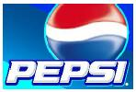

The products manufactured by Tripty drinks Pvt. Ltd, are very limited in range as it is not independent to diversify its products when required. This is because it is a unit of PEPSI FOODS LIMITED, which supplies the concentrates for different brands of soft drink.
These are:-
- PEPSI (cola flavour)
- MIRINDA (orange, apple & lemon flavour)
- 7 UP (Clean lemon flavour)
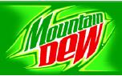
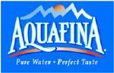
- SLICE (Mango flavour, having concentration of ALPHANSO,TOTAPURI
Mango 30:70)
- SODA EVERNESS
- MOUNTAIN DEW
- PEPSI BLUE
The chief consumers are young masses. Beside direct consumer, hoteliers, restaurants owners and various other soft drinks peddlers also use them. Thus it can be said that these are the product for mass consumption.

2.10- PRODUCTION PROCESS

Water Treatment Plants:
Water in theTripty drinks Pvt Ltd. is coming from Mahanadi River. It is stored in a reservoir. Before ensuring production, this raw water is being treated in the water treatment plant. The process involved is known as coagulation process. Main chemicals used are Ferrous Sulphate (FeSo4), Calcium Hydroxide (CaOH), & Chlorine (CI).
Initially water is treated with all these chemicals in the treatment tank and becomes turbid. All impurities get settled at the base and remove the turgidity. Then it sent to the Carbon Tank where all the microorganisms and chlorine’s are removed. The water so obtained is completely free from any kind of impurities and can be used in further processing. The maximum alkalinity maintained until as much as 50ppm.

Bottle Washing Plant:
Used bottles returning from the market are stealthy. It is completely an auto-process which takes place within a machine called washer machine. The machine has three compartments. Bottle for washing are placed on the conveyer come inside the machine and get successive treatment. Bottles are treated with 4% caustic soda in the first compartmental a temperature 100-150 F. Next these were conveyed to the second compartmental, where bottles are again treated with 2% caustic soda at a temperature of 120F, in the third compartment bottles are treated with soft water. Time duration in each compartment is 10 minutes. Bottles are then sent through the inspection center, where these are watched against strong light.
Syrup Room:
Syrup room is situated on the first floor. Here syrup is prepared from filtered water, sugar and the concentration. The room is well equipped with several tanks and filter press. The first one is “Heating Tank” in which syrup is actually prepared. Calculated amount of syrup along with concentrate and water are being heated up to 85 degree C. Thus a saturated solution is being prepared. Next it is sent through a machine called “Filter Press” syrup is filtered here.
Filtered syrup is next passed through a para flow cooler, when by recycling and glycol method, the temperature of the syrup is cooled down to 20-25 degree C cooled syrup is than stored in the syrup tanks. Syrup comes to the Traumatic machine. Here syrup is mixed with carbonated water under pressure in definite proportion. Inspected bottles gradually come under the “Filtration Machine”. Carbonated syrup by this time fills the filler machine. From this machine, syrup is poured into the bottles in calculated amount. The exact rate of filling is 620 bottles per minute. Meanwhile, crowner machine helps in closing the bottle mouth with helps of the caps completely air tight. Ready bottles are again sent through an inspection center for through examination on conveyer. Next they were carried on a round table from where they are collected.

Chapter-3

(Empirical Study)

3.0- DATA ANALYSIS AND INERPRETATION
Fig: 01. This figure represents total no of outlet visited
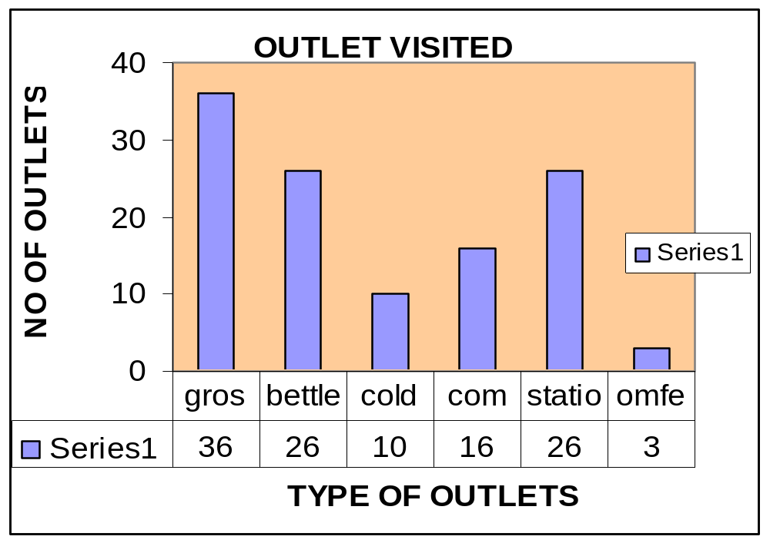

I had visited 100 outlets in different part of Cuttack town from Sikharpur, Gandarpur, New Malgodown, Chauliaganja, Bidhayadarpur, C.R.R.I, Badambari, Ranihat, Manglabag, Medical road, Rajabagicha, Janjirmangla, Ring road, Purighat, Ganesh ghat, Sun shin field, Town hall, Choudhari bazaar, Bangali sahi, Firing bazaar, Nayabazar, B.K.ROAD, Gamandia to Samantasahi and others. In them grocery outlets was 36 in number , bettle outlets was 26 in number, cold drink parlour was 10 in number, commercial shop was in 16 in number and stationary and Omfed parlour was 26 and 3 in number respectively. These outlets are in the part of Pepsi space club programme.
In the criteria 1 – (Space club rack) it was necessary that minimum 15 bottles should be there. Points: 25
Total points: 2500
Points gain by retailer: 1250.
Success rate of criteria 1: 50%

Fig: 2
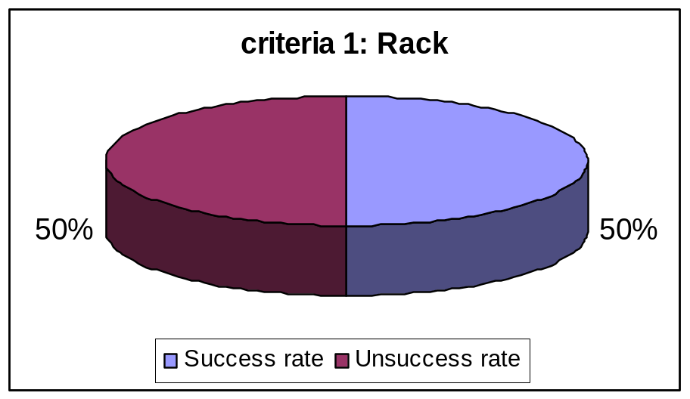

In this condition I have found that the retailers were more or less display the pet bottles properly. In some stores pet bottles was not there but the retailers display the product well. So in Cuttack town the success rate is 50%.
In the criteria 2 (warm crate stacking) it was necessary that minimum 5 crate stock should remain there. Points: 25
Total points: 2500
Points gain by retailer: 2250
Success rate of criteria 2: 90%
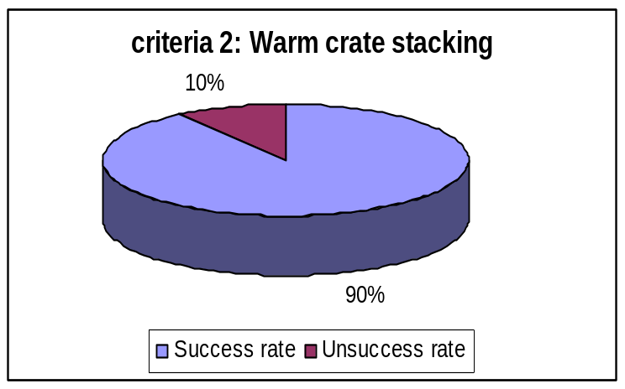

In this condition I have found that 90% of retailer had display the product properly and warm crate stock had more than 5 crate stock remain outside their outlets. So the success rate is above 90 percent.
In the criteria 3 (cold stock> 60%) it was necessary that in retail outlet, in freeze cold stock remain more than 60 percent. Points: 25
Total points: 2500
Points gain by retailer: 2000
Success rate of criteria 3: 80%
Fig: 4
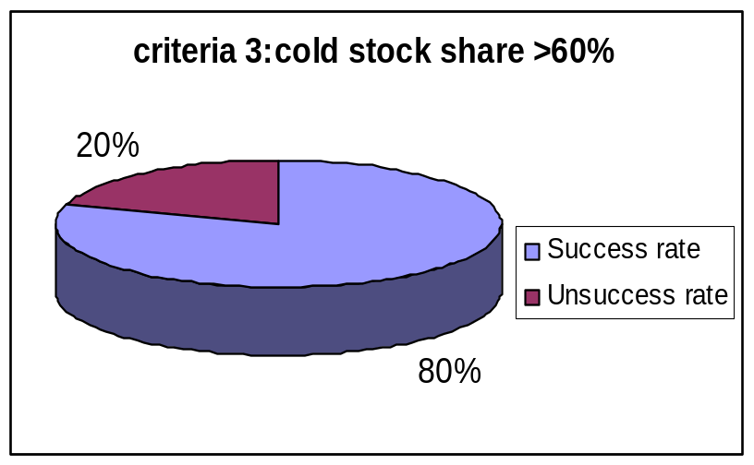

In this condition I had found that 80% retailer outlets the percentage share of cold stock was greater than 60% and in monopoly counter the percentage was above than 90%. So success rate in these criteria was 80%.

Finally if we see the above results than we can easily analyze that the overall performance of Pepsi space club in Cuttack town was greater than 75%.
Total points: 7500
Total points gain by the retailer (100 in nos.): 5500
Success rate in overall: 75%.

Fig.: 5
Overall performance of Pepsi space
Club in Cuttack town
75%
25%
Success
Unsuccessful

Therefore we can say that, particularly this sales promotion technique (Pepsi- Space club) of Tripty drinks pvt. Ltd. was quite impressive and it has performed good in Cuttack town

Fig: 06.This shows three types of outlet – 56 mixed, 34 Pepsi & 29 are coke (monopoly)
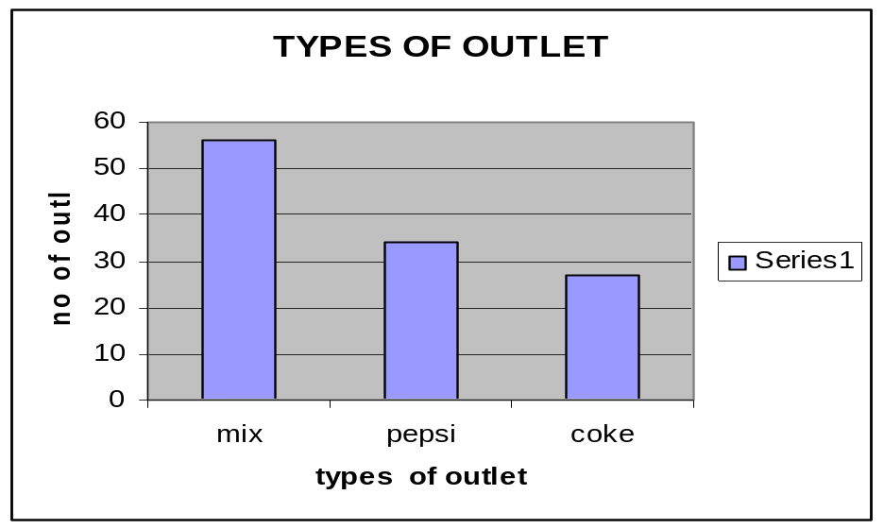
In Cuttack town I visited more than 100 outlets in which mix counter was 55-60 in number and monopoly counter of Pepsi was 34 in number and 29 are coke monopoly counter. The monopoly counter of Pepsi was provided every display items like Pepsi freeze, glow sign board, rack etc.

Fig: 07: This figure represents that; the most selling cold drinks in that region.
% SALES ON EACH BRANDS OF COLD DRINKS
23%
17%
13%
19%
8%
10%
5%
7%
3%
5%
8%
Thums Up
pepsi
Sprite
7 Up
Fanta
Coke
mnt.dew
Mirinda
mazza
Limca
Slice

In Cuttack town after visited 100 outlets I had found that most people prefer Thumps Up, which captures the market share of 23%. Again Pepsi capture the market share with 17%. Sprite captures the market share with 13%. Again most people prefer 7-up and market share was 19%. Fanta also popular and it sales was 17%. Coke captures 10% as well as Mountain dew was 5%. Besides that Mirinda occupies 7 % and Mazza occupies 3%with Limaca and Slice has 5% and 8% respectively. So overall we can found that Thumps-up and Pepsi has

Fig: 08: This figure represents the most selling product of PEPSI.
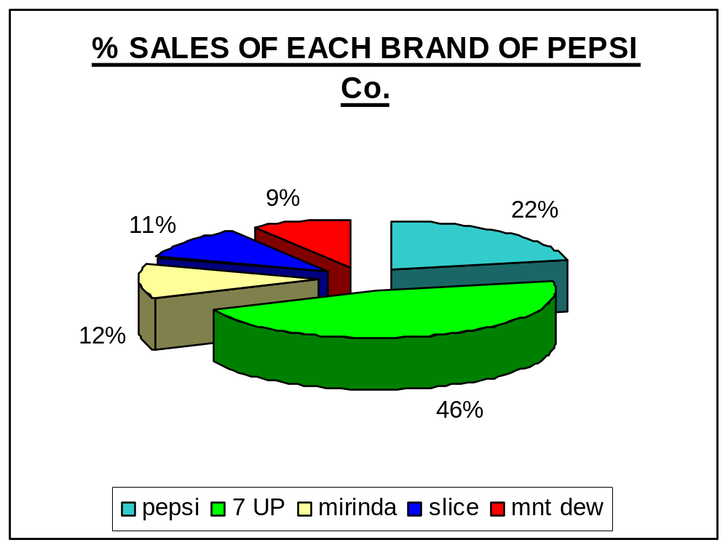
In Cuttack town the selling of Pepsi soft drink was quite impressive. When I had asked the retailer about the sales of Pepsi brand then most of them told that 7-Up was most selling brand. It occupies about 46% in total market share. Next was Mirinda which capture 12%. Pepsi was also popular and it occupies about 22%. Slice and mountain dew has 11% and 9% respectively. So from above analysis we can found that 7 Up was a most popular and it sales was quite impressive.
Other flavour of Pepsi brand was also quite selling and most popular brand. Most of the consumer of different age group prefer 7-up and slice. But Pepsi was not so prefer by the different age group people.

ANALYSIS OF THE RETAILERS’ QUESTIONNAIRE:-
Q.1 How much stocks available?
From this question I find out the demand of a product they keeps the more Pepsi than the Coca-cola.
Q.2 Which company have provide you the chilling equipment?
Through this question I tried to ask about the promotion in the Nuabazar market.In the return I got to know that 60% retailers uses the visi of Coca-cola,30% uses the Pepsico visi and 10% uses own visi.
Q.3 Which company have provide you the rack?
In this I got to know that 40% retailers uses Pepsico rack and 50% uses Coca-cola rack and 10% don’t have any rack.
Q.4 Doyou know CE’s name?
This question is for analyzing how the people knows and satisfied with the CE of the both company.In return I got to know that 60% people know the name of the Pepsi CE and 70% knows the Coca-cola CE.
Q.5 How satisfied are you, with the Signage?
Signage is the main source of advertisement.In Cuttac Pepsi have given 30% of GSB,Coca-cola have 25% GSB,rest having own or no GSB.About the plain board Pepsi have provided 40% boards,Coca-cola provided 50% of plain board.
Q.6 How satisfied are you with the SCHEMES of PEPSI?
This is another question which tell us about the opinion of the dealers for Schemes, which is provided by the company to push the product and generate the sale of product in the market. So after analyzing this question I found that 62% of dealers are very satisfied with the schemes, 27% are quite satisfied, 6% dealers are neither satisfied nor dissatisfied, 5% of dealers are quite dissatisfied and I glad to find out that there is no one dealer which is fully or very dissatisfied with the schemes facility of Pepsi.
Q. 7 How satisfied are you with the GLOW SIGN BOARD of PEPSI?
This question talk about the glow sign board, which are the boards on the top of a shop with neon lights in the back ground with works as a sign board for the shop. After analyzing this question I found that 20% of the dealers are very satisfied with the glow sign board, 12% are quite satisfied, 10% are neither satisfied nor dissatisfied, 50% are Not satisfied and finally 8% of dealers are very dissatisfied with the glow sign board.

Q.8 How would you rate COKE compared to PEPSI on SCHEMES?
In this I tried to find out the opinion of the dealers about the schemes of Pepsi in compare of Coke and I found that for 23% of dealers told that Coke has good scheme in this season. 77% dealers told that Pepsi provide good scheme in this summer as for example scratch card system.
Q.9 What is the result of Brand pull?
In this Brand pull I anlysed that the pepsi brand position is in average.80% of the retailers think it is in average.

Q.10 Which company gives better service?
In this questions I analised that 60% thinks Pepsi provides better service and 40% thinks that Coca-cola provides better service.

Q.11 Frequency of salesman?
By asking this question I got to know that the frequency of both the company salesman are approximately same.Both the company sales man covers 3 to 4 times a outlate in a week.

Q.12 Which company gives better scheme?
In his answer I analised that 45% thinks Pepsi provides better scheme and 55% thinks that Coca-cola provides better scheme.

Q.13 Which schemes do you like the most ?

Q.14 Any senior officials visit ,?
By the answer of this question I got to know that ,the officials of both the company visits in every 3 to 4 months to know about the product and sales status.

Q.15 Support material (holders, displays etc.)?
With the help of this question I tried to found out that how many a dealers are satisfied with the support material, provided by the Pepsi. The opinion of dealers are divided into three main parts, which are, provided no support material, provided low quality of support material and assistance and provided high quality of support material and assistance to help his business.

Q.16 Which brand of water you sells more ?
With the help of this question ,I got to know that in Cuttack many of the retailers sales more local brand of water .Because it gives more profit &also the cost of Aquafina is too much as compared to the local brands.
Q.17 Per day sales in peak time & annual volume of sales?
From this question I got to know the demand of Pepsi in Cuttack. In Cuttack the per day sale of a small betel shop is 4 to 5 case per day in RGB and approx 7 to 8pcs a PET .And the rest a days they sales approx 1 case in RGB and 2 to 3 pcs of PET.

Chapter-4

(Findings, Suggestions & Conclusion)

4.0- FINDINGS
The collected data which were analyzed came out with the following conclusions:-
- It is found that some outlets perform well in criteria 1 that is display the pet bottles in rack, they display properly in one area then some fails to do perform in another. The reason behind this is that they do not receive any kinds of rack or freeze from company for display the Pepsi products. Some retailers were saying that they have not so much space in their outlets to show the product and some other have space racks but they put other materials on it as they not aware about this scheme. Therefore the company needs to focus to rest 40 % who does not perform well in space club programmed.
- In various outlets the retailers were good response towards distribution of Pepsi. But some of them complain about the distribution. Some say distribution of Pepsi is not properly distributed in time.
- When they need pet bottles (7-up, Miranda) the distributor has not provided at that time.
- And the free offers or gift were not distributed properly to the retailer in which they face problem when customer demanded free gifts.
- Some outlets were complaining about the racks and freeze which is not given to them by distributor but some place there is good response. So more or less there is a good response of retailer towards Pepsi distribution.
- In the city like Cuttack, Pepsi products are reaching to every corner (remote area) where not a single bottle of Coca-cola can be seen.
- Most of the dealers want glow sign and chilling equipments, which they are asking from long time.

- Most of the consumer doesn’t like the taste of PEPSI due to its Sweetness and low fizz.
- Dealers are asking for the incentives and sales promotional schemes.
- Some dealers & retailers stops selling Pepsi products because they are not satisfied with the company, where Coca-cola fulfill some of their demand and got the opportunity to make exclusive counter for the soft drinks.

4.1-Suggestions

- First of all company will provide all its dealers and retailers to all sort of promotion equipment such as glow sign board, banner, rack, freeze, etc. in time so that they increase their sales which is benefited both retailer as well as company.
- The distribution channels need to be improving so that retailer/dealer will get soft drinks at time when they need.
- Salesman should have good interaction with the dealers, which result Company in increase in sales. Company executives should visit the counter on weekly basis. Executives should take the feedback from the dealers about the service of the sales man and the distributors
- Regular visit of technician is required to solve the problems of Freeze in the market at the right time.
- More improvement is required in the distribution network in the outskirt and in the remote areas, because in the peak seasons like summer the small dealers are taking goods twice or thrice and in between if the distributors could not supply them, the competitors will get the opportunities to supply the goods.
- The entire Pepsi product should be displayed at one place so that the customers can aware about the different brand of Pepsi. In the bus stand, railway canteen, highway the CAN and PET Bottles should be made available every time because the publics are busy there and they cannot wait.
- Pepsi is a sweet and low fizz soft drink that everybody knows and so lots of people do not like so to catch the customers Pepsi should come out with more fizz.
- Few outlets are unaware about scheme so proper communication is necessary between distributor and dealers/retailers.
- There should be more focus on 100% avaibility so that Pepsi don’t lose sales & market share.
- All mixed outlets which stock multiple products should be transferred to exclusive Pepsi outlets.
- More & more research should be made to find new segment & more profitable market for the product.
- Kids constitute the second largest segment of the soft drink market. So, more & more fun based advertisement for the brands should be necessary. Some life style based advertisement is also necessary.
- The company strategy should be made in such a way, that maximum no of consumer will prefer to consume Pepsi i.e. give importance to quality control, give more importance to public awareness and in advertisement.
- Dealers are the good intermediaries so the company should give more packages to the dealer, by which they can looks towards the high sales of this particular brand.
- The company should start survey time to time to know the grievances of retailer as well as consumers.
- Some times absence of stocks annoys retailer and consumers, so company should keep a watch to the availability of brand.
- Promotional advertising must include some Indian stars (film & cricket).
- Supply chain should be enhanced more then 100%.
- Fountain should be provided to outlets, which is very much demand in market.

CONCLUSION

Pepsi & its Product Co. are the Profitable MNC’s in not only India but also in the whole world. Its main competitor is Coca-Cola. Pepsi has built a reputation around the world as a major player in the soft drink market as well as the leader in the snack food industry. Currently they are facing stiff competition from Coca-Cola, but with their various marketing ventures as well as the selling of their restaurant franchises, Pepsi is poised to give Coke a definite battle in the future as to which cola consumers want.
Promotional activities play a greater and important role in the entire marketing effort being carried out by Tripty drinks (pvt.) Ltd., “to generate more sales as well as to create and maintain an image of its product”.
Pepsi believes that “Jho Dikhta Hai Woh Bikta Hai” i.e. any product which is visible is bound to be sold This method of sales promotion being used by the Pepsi, through its distributors is to conduct dealer’s sales contest during the peak seasons i.e. during April to July. In it the dealers are given prize in the form of cases of soft drinks and gifts. In the contest at first his or her respective distributors according to there categorize each dealer. And then each distributor fixes a target of minimum sale for each category to which every dealer according to his or her category has to achieve during the contest period.
The dealers achieving highest sales over and above the target set is giving the awards as under, the order of prizes announced are first prize, 2nd prize, 3rd prize in terms of number of free cases of soft drinks and gifts.
Thus Tripty Drinks Pvt. Ltd carried out its promotional activities (in the area of Cuttack) as a controlled and integrated program of communication and material design to present its soft drink to the prospective customer. It also helps in communication the need satisfying qualities of soft drink, to facilitate the sales and eventually to contribute towards the profit in long range and a great display will result in great sales and that is a 100% guaranteed way to add profits .So time to time this type of scheme will help the company to improve the sales in long time.

BIBLIOGRAPHY

BIBLIOGRAPHY

Books:
Kotler, Philip. “Marketing Management” Prentice Hall of India, edition-IX.
Ramaswami, V.S and Namakumari, S. “Marketing Management”. Macmillan, edition-II.

Journal:
Singh, S.K. “A view across global marketing”. India Journal of commerce, volume-54, Number-1&2, January-June 2007.
Indian Management (All India Management Association), January 2007 issues.

Web-sites:
www.pepsi .com
www.corporate .org
www.wikipedia encyclopedia.com
www.india today.com

ANNEXURE

Questionnaire
Name of the distributor :
Name of CE : DT :
1. Name of the outlet :
2. Address :
3. Contact person :
4. Contact number :
5. Filled stock
(RGB) : PCI_________,CCX___________
(PET) : PCI__________, CCX__________
(EMPTY) : PCI___________, CCX________
6. Chilling equipment(Size) : CCX OYC OWNICEBOX
7. Signage :
PCI : GSB DB POP
CCX : GSB DB POP
8. Rack : PCI CCX
9. Better service : PCI___________, CCX_________
10. Frequency of salesman : PCI_____________, CCX________
11. Better scheme : PCI , CCX
13. Senior officials visit : PCI CCX
14. Which brand of water do you sell more :
Aquafina Kinley Bisleri Local Pouch
15. Brand pull : 1 2 3 4
16. Any survey by third party in monthly basis : Yes No
17. Per day sell in peak month : RGB______________PET___________
18. Annual volume : RGB_______________ PET__________________
19. Which scheme do you like the most ;
Refilling scheme Scratch card UTC QPS Display scheme
20. Any change do you feel in 200-08 :
21. Why are you selling only Pepsi/Coke product :
22. Any suggestion :

Date Retailer’s signature

