Competitive Exams Books
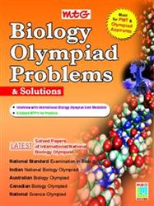 | Mtg Biology Olympiad Problems & Solutions  by Dr. Sandeep Ahlawat
  Price: | 200
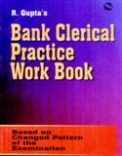 | Ramesh Bank Clerical Practice Work Book  by RPH Editorial Board  Top of Form    Bottom of Form
  List Price: | 240
    10%
    off
  Price: | 216/-
  You Save: | 24 ( 10% )
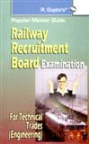 | Ramesh Railway Recruitment Board (Tech.Engg. Cadre) Exam Guide  by RPH Editorial Board  Top of Form  Bottom of Form
  List Price: | 250
    10%
    off
  Price: | 225/-
  You Save: | 25 ( 10% )
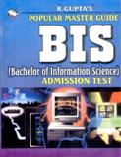 | Ramesh BIS Entrance Exam Guide  by RPH Editorial Board  Top of Form  Bottom of Form
  List Price: | 270
    10%
    off
  Price: | 243/-
  You Save: | 27 ( 10% )
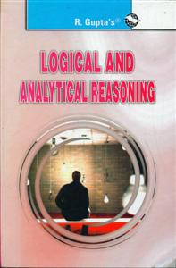 | Ramesh Logical and Analytical Reasoning  by A. K. Gupta  Top of Form  Bottom of Form
  List Price: | 95
    10%
    off
  Price: | 85/-
  You Save: | 10 ( 10% )
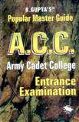 | Ramesh ACC Entrance Exam Guide  by M. L. Batura  Top of Form  Bottom of Form
  List Price: | 230
    10%
    off
  Price: | 207/-
  You Save: | 23 ( 10% )
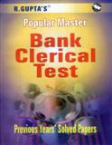 | Ramesh Bank Clerical Exam Solved Papers  by RPH Editorial Board  Top of Form  Bottom of Form
  List Price: | 195
    10%
    off
  Price: | 175/-
  You Save: | 20 ( 10% )
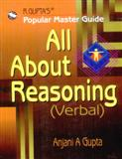 | Ramesh All About Reasoning (Verbal)  by Anjani A Gupta  Top of Form  Bottom of Form
  List Price: | 215
    10%
    off
  Price: | 193/-
  You Save: | 22 ( 10% )
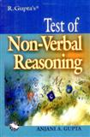 | Ramesh Test of Non Verbal Reasoning  by Anjani A Gupta  Top of Form  Bottom of Form
  List Price: | 95
    10%
    off
  Price: | 85/-
  You Save: | 10 ( 10% )
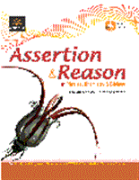 | Arihant Assertion & Reason for Medical Entrance Exams (C065)  Top of Form  Bottom of Form
  List Price: | 195
    10%
    off
  Price: | 175/-
  You Save: | 20 ( 10% )
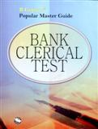 | Ramesh Bank Clerical Test Guide  by Anjani A Gupta  Top of Form  Bottom of Form
  List Price: | 240
    10%
    off
  Price: | 216/-
  You Save: | 24 ( 10% )
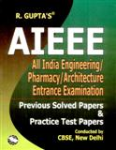 | Ramesh CBSE AIEEE Previous Years Solved Papers & Practice Papers  by RPH Editorial Board  Top of Form  Bottom of Form
  List Price: | 310
    10%
    off
  Price: | 279/-
  You Save: | 31 ( 10% )
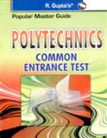 | Ramesh Polytechnic C.E.T. Guide  by RPH Editorial Board  Top of Form  Bottom of Form
  List Price: | 260
    10%
    off
  Price: | 234/-
  You Save: | 26 ( 10% )
 | Oswaal Chapter Wise Solutions CAT Previous Years Solved Papers  by Panel of Experts  Top of Form  Bottom of Form
  List Price: | 379
    20%
    off
  Price: | 303/-
  You Save: | 76 ( 20% )
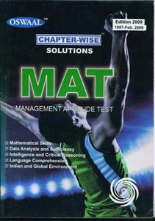 | Oswaal Chapter-Wise Solutions of MAT (1996 - Sep. 2010) Solved Papers  by Panel of Experts
  List Price: | 499
    20%
    off
  Price: | 399/-
  You Save: | 100 ( 20% )
 | Arihant UP SEE Entrance Exam Solved Papers (C072)  by Editorial Board  Top of Form  Bottom of Form
  List Price: | 335
    10%
    off
  Price: | 301/-
  You Save: | 34 ( 10% )
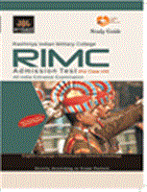 | Arihant RIMC (Rashtriya Indian Military College Dehradun) Admission Test (Self Study Guide)  by Editorial Chief Maj.R.D. Ahluwalia  Top of Form  Bottom of Form
  List Price: | 190
    10%
    off
  Price: | 171/-
  You Save: | 19 ( 10% )
 | Arihant Indian Army MER Soldier Nursing Assistant Recruitment Exam  by Maj.R.D.Ahluwalia  Top of Form  Bottom of Form
  List Price: | 120
    10%
    off
  Price: | 108/-
  You Save: | 12 ( 10% )
Arihant Sainik School Admission Class 9
by Editorial Board Chief in Maj. R.d. Ahluwalia
List Price: | 255
  10%
  off
Price: | 229/-
You Save: | 26 ( 10% )

Top of Form
Bottom of Form
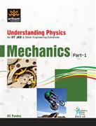 | Arihant Mechanics Part-1 For IIT JEE & Other Engineering Entrances (B021)  by D.C.Pandey  Top of Form  Bottom of Form
  List Price: | 295
    10%
    off
  Price: | 265/-
  You Save: | 30 ( 10% )
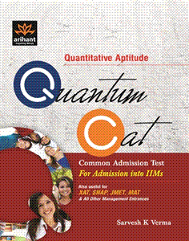 | Arihant Quantum CAT For Admission into IIMs (D104)  by Sarvesh Kumar Verma  Top of Form  Bottom of Form
  List Price: | 615
    10%
    off
  Price: | 553/-
  You Save: | 62 ( 10% )
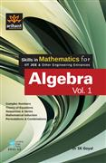 | Arihant Algebra Vol-1 For IIT JEE & Other Engineering Entrances (B013)  by SK Goel  Top of Form  Bottom of Form
  List Price: | 375
    10%
    off
  Price: | 337/-
  You Save: | 38 ( 10% )
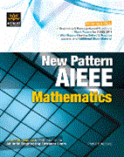 | Arihant New Pattern AIEEE Mathematics (B065)  by Prafull Agarwal  Top of Form  Bottom of Form
  List Price: | 610
    10%
    off
  Price: | 549/-
  You Save: | 61 ( 10% )
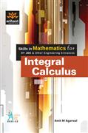 | Arihant Integral Calculus For IIT JEE & Other Engineering Entrances  by Amit M. Agarwal  Top of Form  Bottom of Form
  List Price: | 310
    10%
    off
  Price: | 279/-
  You Save: | 31 ( 10% )
 | Arihant Study Package for NIIFT NID & IIFT Entrance Exams  by D. Mittal, Shiv Raj Singh, M. Sharma & A. D. Srivastava  Top of Form  Bottom of Form
  List Price: | 410
    10%
    off
  Price: | 369/-
  You Save: | 41 ( 10% )

