As you want here I am giving below process to do download Food Corporation Of India Watchman Exam call letter

Go on Food Corporation Of India official website
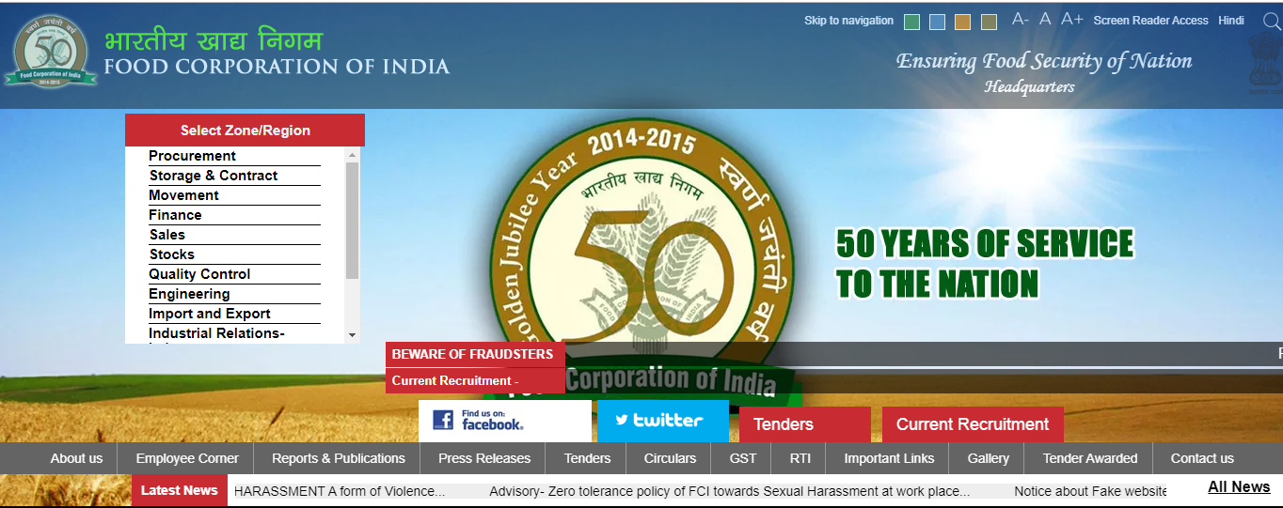

Now click on Direct Link to Download Gujarat FCI Admit Card/call letter.

Fill all details in form like registration No. & Password.

Click on Submit button.

Now your Gujarat FCI Call Letter shown on screen.

Download IT & Take a print out for future use.

Following info will be avail in call letter
Applicantâ€™s Name

Roll No.

Registration No.

Exam date & Time

Venue of Exam

Photo & signature

Other Instruction etc.

