As you want here I am giving below process to do download Karnataka Bank Recruitment Challan form on your demand :

Go on Karnataka Bank official website

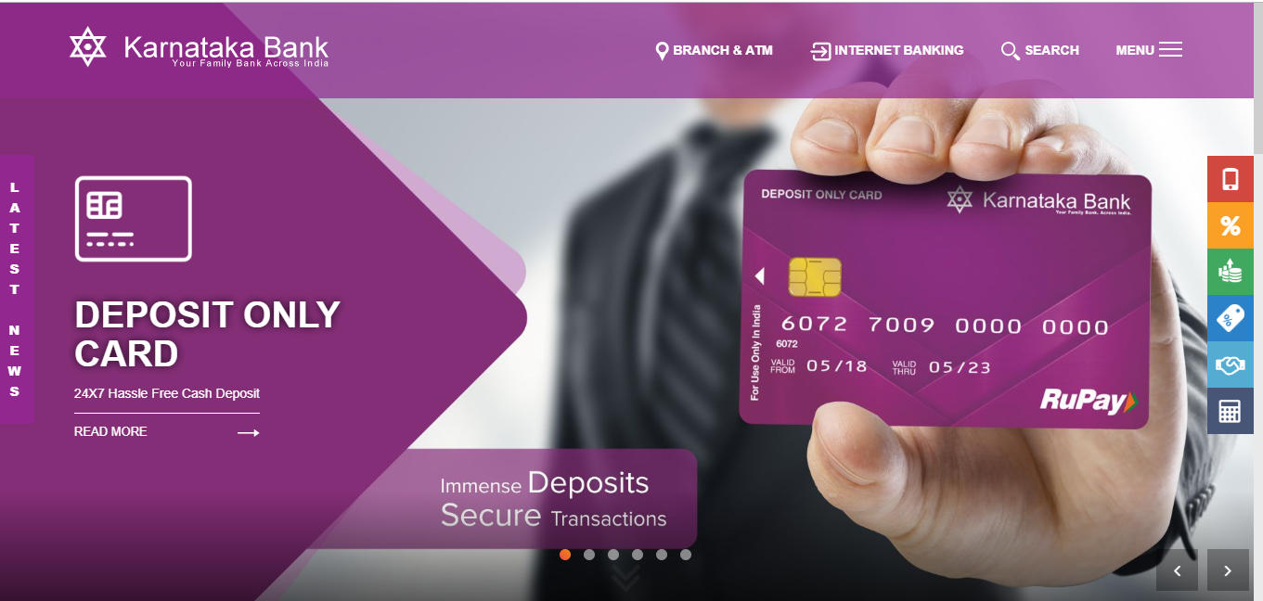

Click on application form link on home page

After it take printout of challan format from the official website of Karnataka Bank.

Then you need to go to Bank and pay the required fee according to your category(SC/ST/General/OBC)

In Bank you will get Challan receipt and then you are required to enter the challan number while filling the online application form.

Bank profile:

Type Private Sector Bank

Traded as BSE: 532652

NSE: KTKBANK

Industry Banking, Financial services

Founded 1924; 94 years ago

Headquarters Mangaluru, Karnataka, India

Key people Shri Mahabaleshwara M. S

(M.D & C.E.O)

Products Retail Banking, Corporate Banking, Finance and Insurance,Credit Card,
Mortgage loans, Private banking, Wealth management, Investment banking

Revenue 5,185.40 crore (US$790 million) (2017)

Operating income 995.80 crore (US$150 million) (2017)

Net income 452.26 crore (US$69 million) (2017)

Total assets 64,126.54 crore (US$9.8 billion) (2017)

Number of employees 7,982 (2017)

Capital ratio 13.30%

